|  |  |
| --- | --- |
| Command | Input File |
| concat | student_details.txt(Attached with git hub link) |
| tokenize | student_details.txt |
| sum | student_details.txt |
| min | student_details.txt |
| max | student_details.txt |
| limit | student_details.txt |
| store | student_details.txt |
| distinct | Student1_details1.txt(Attached with git hub link) |
| flatten | student_details.txt |
| isempty | File1.txt andFile2.txt(Attached with git hub link) |

1. Concat Command :

To start pig shell (pig –x local)



-Loading a data(student_details.txt) to pig

“student_details = LOAD '/home/acadgild/hadoop/student_details.txt' USING PigStorage(',') as (id:int, firstname:chararray, lastname:chararray, age:int, phone:chararray, city:chararray, gpa:int);”



-Dumping a data

DUMP student_details;



Output of “DUMP student_details;”

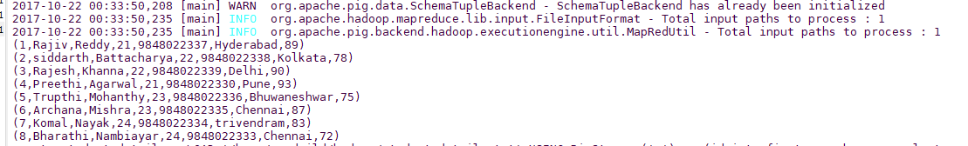

-Running concat command “student_name_concat = foreach student_details Generate CONCAT (firstname, lastname);”

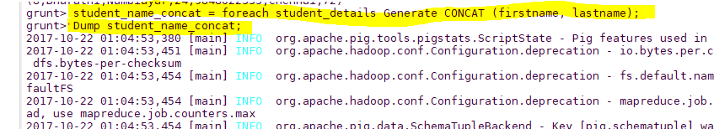

Output of “student_name_concat”

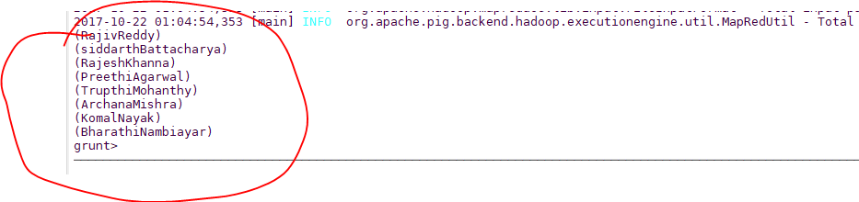

2)Tokenize Command

To tokenize the firstname

-tokenize_data = foreach student_details Generate TOKENIZE(firstname);

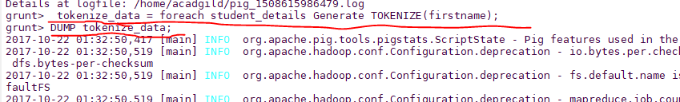

Output of Tokenize

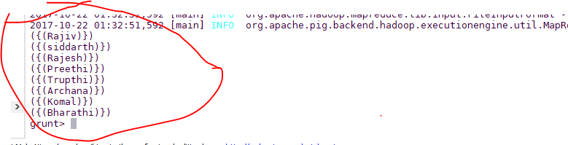

3)sum

-student_group = Group student_details all;

-student_age_sum = foreach student_details Generate (student_details.firstname,student_details.age),SUM(student_details.age);



Output

-DUMP student_group;

-DUMP student_age_sum;





4)Min

-student_group_all = Group student_details All;

-student_gpa_min = foreach student_group_all Generate (student_details.firstname, student_details.gpa), MIN(student_details.gpa);

-Dump student_gpa_min;

Output

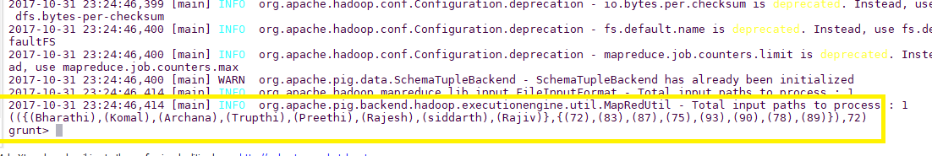

5)max

-student_gpa_max = foreach student_group_all Generate (student_details.firstname, student_details.gpa), MAX(student_details.gpa);

-DUMP student_gpa_max;



6)limit

-limit_data = LIMIT student_details 4;

-Dump limit_data;

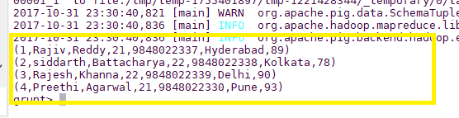

7)store

-STORE student INTO ' /home/acadgild/hadoop//pig_Output/ ' USING PigStorage (',');

-Sh ls ‘/home/acadgild/hadoop/pig_Output’

-Sh cat ‘/home/acadgild/hadoop/pig_Output/part-m-00000’

Output



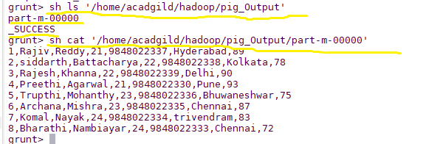

8)Distinct

-student_details1 = LOAD '/home/acadgild/hadoop/student_details1.txt' USING PigStorage(',') as (id:int, firstname:chararray, lastname:chararray, phone:chararray, city:chararray);

-DUMP student_details1;

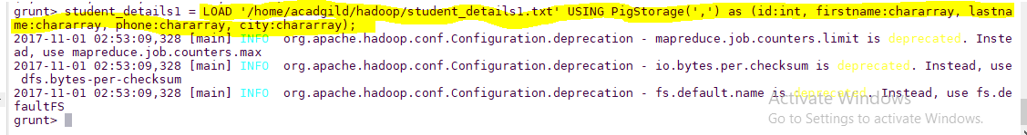

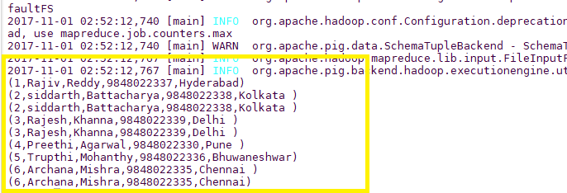

-distinct_data = DISTINCT student_details1;

-DUMP distinct_data;

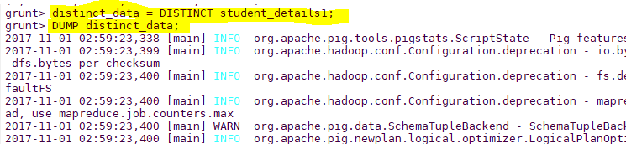

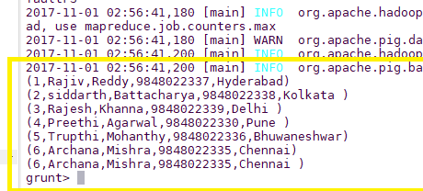

9)Flatten:

-student_details = LOAD '/home/acadgild/hadoop/student_details.txt' USING PigStorage(',') as (id:int, firstname:chararray, lastname:chararray, age:int, phone:chararray,

-student_file = FOREACH student_details GENERATE FLATTEN(TOKENIZE(firstname)) as word;

-DUMP student_file;

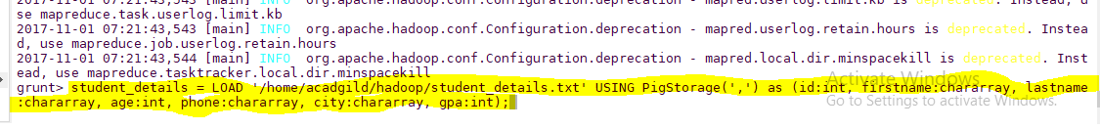

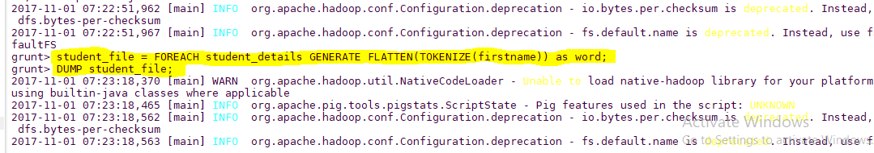

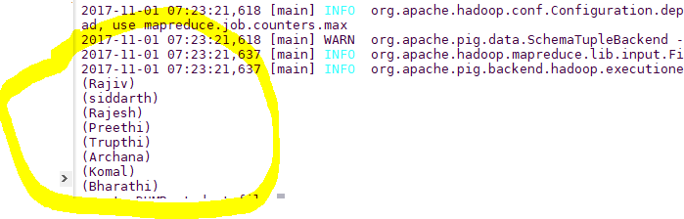

10)IsEmpty

emp_sales = LOAD '/home/acadgild/hadoop/File1.txt' USING PigStorage(',') as (sno:int, name:chararray, age:int, salary:int, dept:chararray);

emp_bonus = LOAD '/home/acadgild/hadoop/File2.txt' USING PigStorage(',') as (sno:int, name:chararray, age:int, salary:int, dept:chararray);

DUMP emp_sales;

DUMP emp_bonus;

cogroup_data = COGROUP emp_sales by age, emp_bonus by age;

DUMP cogroup_data;

isempty_data = filter cogroup_data by IsEmpty(emp_sales);

DUMP isempty_data;

Screenshot

-emp_sales = LOAD '/home/acadgild/hadoop/File1.txt' USING PigStorage(',') as (sno:int, name:chararray, age:int, salary:int, dept:chararray);

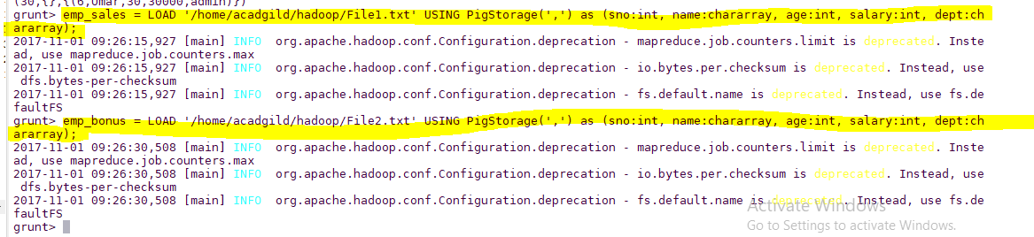

-DUMP emp_sales;

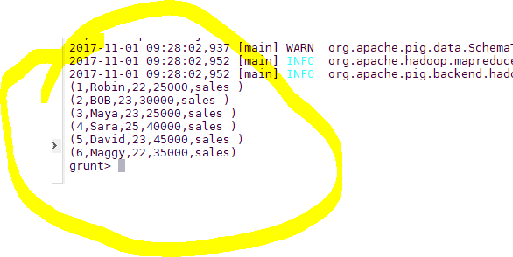

-DUMP emp_bonus;

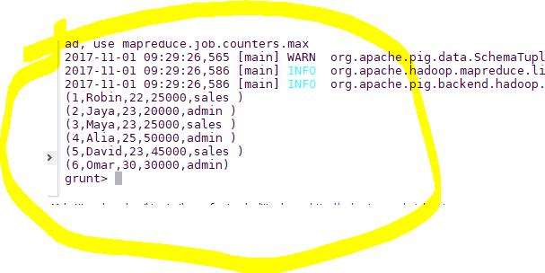

-cogroup_data = COGROUP emp_sales by age, emp_bonus by age;

-DUMP cogroup_data;

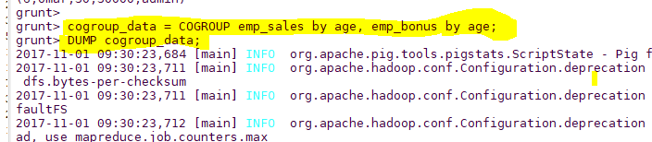

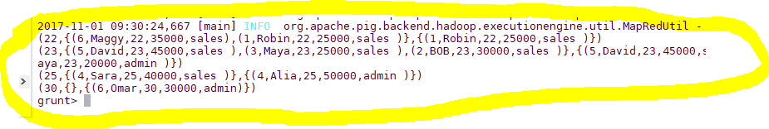

-isempty_data = filter cogroup_data by IsEmpty(emp_sales);

-DUMP isempty_data;

